The Law of Diminishing Returns
Zvi Mowshowitz
Invasion Rochester is radically different from any previous draft format. The primary reasons for this are the gold cards and cards with activation costs in different colors. Cards come and go, and the strength of the colors wax and wane over different sets. Suddenly, there are only five two-color combinations worth drafting, and many players are going with three colors or more. Aside from knowing what decks are worth drafting and how to draft them, you also need to know what others will try to draft and how to anticipate and manipulate them. Separating what cards are worth from what other players think they are worth is even more critical than ever if you want to get better picks coming back and, even more importantly, it lets you have much better control over people's color choices. This is a closer look at what to do when a card is incorrectly valued, or is unusually valuable for the deck being drafted.

Separating what cards are worth from what other players think they are worth is critical...
As a historical example of an incorrectly valued card, the standout would be Falter. At first glance, it didn't seem like it was a playable card; all it did was stop creatures from blocking for one turn. A turn later, you'd lost a card without taking one out or drawing one in return. You lost card advantage. Most cards like this are extremely bad. You use up a card, and your opponent takes a few points of damage. Big deal. But Falter turned out to be an amazing card in practice. Except for the occasional flying blocker, attacking with a red army would often allow you to do double digit damage. If you could get damage in early, you could then sit back building up your creature base until you went in with Falter for the kill.
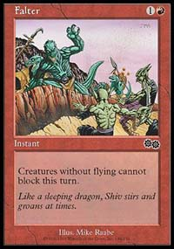
Some players realized this quickly. But others continued to consider it a very low pick, and they drafted it as such. Falter would go as late as fifteenth sometimes, as player after player took an unplayable or marginal card in his or her own colors instead. Now consider how this affects someone who wants Falter for his or her deck, and knows its true power as an early pick. That player's evaluation of the card will go down radically. There's a chance the Falter will come back around. Often, players in these situations will think in terms of a gamble: they can make the safe play and take the card they want, or take the second best card and hope to get both.
But it's not just an issue of the card coming back later in the pack. The biggest other issue is that there will be other packs of the same set. Early on in a draft, there could be as many as twenty-three additional chances for another copy of a card to be opened, and in the extreme situation where no one else will touch the card, it will be available no matter who opens it. Almost all cards follow the law of diminishing returns. The first Falter will generally help your deck more than the second, and the third or fourth Falters quickly become counterproductive. Even for a card that would seem not to have this problem, such as Tower Drake, has it as well. Tower Drake is a solid creature, and having two of them might even be more than twice as good as one because they both are white mana intensive; by having both, you can justify more white mana. This works in the same way that it's better to have all of a deck's cards be the same color. Even having four or five of them is pretty good. But if a deck were to have seventeen of them, it would have a horrible mana curve, a rather annoying mana base and have serious trouble dealing with ground assaults or flyers with three toughness.
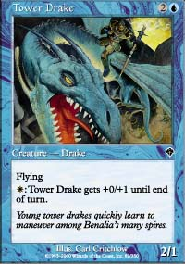
Tower Drake actually holds up remarkably well, because it can perform in a lot of different roles. But move to something like Serpentine Kavu, which is still an excellent creature and capable of winning games on its own, and the problem becomes more acute. Every deck has a quota of each type of card that it wants to give it the right card mix. The easier a card is to draft late, the greater the chance that taking an early pick to get one will go to waste. Drafting two late pick Falters makes an otherwise excellent fifth pick Falter no longer worth it. The earlier in the draft and the more packs of the same set are being drafted, the more players with strange evaluations of cards need to conform to the standard view of them due to this effect. When time starts to run out and the chance of picking up a copy free becomes slim, this becomes less and less important.
The other problem works in a similar way. Every time a pick is made, it means more than just a card that player can add to his deck after the draft. It also works as a signal and it affects the options of other players. Sticking to Rochester, the signaling effect is the more important one in the first part of the draft. The signal a card sends depends on what the player reading the signal thinks of the card. If you take a Tower Drake, that's clearly a signal you want to go blue. But it also hints that you want to go white. How serious that secondary signal is depends on the view of the person reading the signal. If he thinks Tower Drake is a worthwhile pick even if its ability cannot be used, the white signal will probably be considered minor. If the pick doesn't seem to make sense in a deck without white in it, it becomes a clear white signal as well as a blue one. In the case of Tower Drake, most players will probably judge it as a worthwhile card that gets even better with white; a sign of a slight leaning toward white over black but nothing definite. But if the card was something like Thornscape Apprentice, it's generally clear that the card was taken so that its ability to tap creatures for white mana could be used. So the signal would be both green and white. If its red ability was something better (such as tapping to do one damage to target creature and one damage to you) then it would be unclear why the card was taken.
This is a clear green/white signal
Beyond that, players are doing more than just indicating their colors and strategy within those colors. They're also trying to send the signal 'I know how to draft.' Normally drafters don't think about this part of the draft, because drafting normally should send this signal without any need to worry about it. Still, sending this underappreciated signal is vital! It's never really missed until it isn't there. Suddenly, the other players start to think the person next to them is a scrub. This makes them much less respectful of his colors, and much more likely to fight for them. Who cares if someone on my right is drafting my colors if they're always taking bad cards? Even an assessment of being less than top-notch in card assessment will make experienced players more willing to fight. Other aspects of skill assessment have other effects on the draft, but this is the one most worth watching out for.

Players are constantly trying to send the signal 'I know how to draft'
A similar problem is options. If Falter and another playable red card are in the same pack, what I take now will have a direct impact on whether other players will end up with what they consider a playable red card. The more playable red cards they think they have, the more likely they are to draft red. Most players will let the options for their first pick have a much bigger impact on their color choice than they should. It's obvious that choosing the right colors for the entire draft given your position is worth far more than any solid card could be, but this fact is lost on most drafters. So taking that other red card will actually make them much more likely to end up in red, and making that red card better makes them much more likely to take it. This works both ways. If there's a card that players are overvaluing, passing that card becomes dangerous and it may be necessary to draft it just to prevent it falling into the wrong hands.
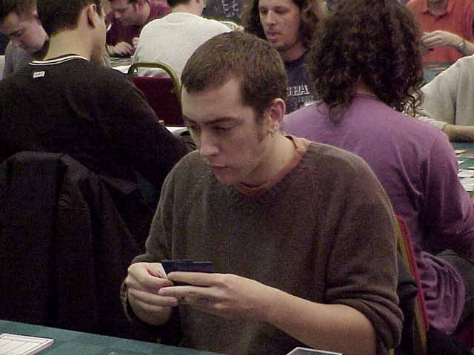
A real life example that ties together many of these issues would be the second draft of the PTLA when we were drafting Urza's Saga. I was in a middle position at a table of players with 3-1 records, and David Price was on my left. As I stated in my previous article on The Rule, most good players in this tournament planned to draft black if at all possible. For an early pick of the draft, I had a choice between Phyrexian Ghoul and Despondency. Both were solid additions to black decks, but in general Despondency was (rightly) considered a much better card. At this point, I had several good tricks but no creatures. I decided that it was worth taking Phyrexian Ghoul over Despondency in order to balance my deck.
Big mistake.
I'm still not sure if I made the right choice purely for my deck, but it had a huge effect on the draft that more than made up for any direct gains for my deck. David Price saw me pick Phyrexian Ghoul over Despondency, and he had not yet committed to both of his colors. He thought to himself: "Zvi does not appear to know how to draft this set. I now have a chance to pick up a Despondency, which is a much better reason to start drafting black than Phyrexian Ghoul, and I expect Zvi to pass me cards he should have drafted. So given that black is so good, I'll fight for it." It turned out I knew how to draft pretty well, but the damage was done; we both drafted black. It almost got worse, because it looked like I might have to draft black/green and that would have meant fighting him for both of his colors. Instead, I resisted temptation and stuck to white. The end result was that even though we both knew how to Rochester and tried to stay out of each other's way, both of our decks suffered.
Now move from old cards like Falter to a modern example, Savage Offensive. Most people who first look at this card think it's decent, but then they realize that it's a sorcery and not an instant. As an instant, it would clearly be a good combat trick, killing opposing creatures with First Strike and the extra point of damage. But as a Sorcery, the card gives the opponent the chance to block knowing that all attacking creatures have first strike and +1/+1. He'll plan, block accordingly, and maybe take a little extra damage. At this point, most players are ready to throw this card in the trash. But I've had the card played on me, and it turns out to be surprisingly, well, savage; WotC did a great job staying ahead of the curve on Magic lingo here. By making it extremely difficult to block any decently sized creature without either throwing a creature away or making a poor creature trade, it very often turns out to be well worth a card if used carefully. It's no Falter, but it's a similar situation.
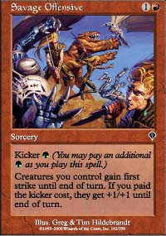
The new Falter?
Right now, Savage Offensive is a pure 15th pick; most players will try and let you have as many as possible to encourage you to both draft those colors and to play the Savage Offensives in your deck, thinking they'll do far more harm than good. But that's not the case. A player drafting a R/G aggressive ground assault deck with the proper mix of creatures probably wants to play one or maybe even two of them. Early on, there's no reason to take an Offensive with other worthwhile cards on the table, unless the deck wants to draft three or more. They will come for free, the same way Falter did. Later on, the card will be rated higher and higher until it is drafted for its actual value and not its perceived value. This coincides with the other issues. The later in the pack or the draft that a Savage Offensive is drafted, the less likely someone will start to think they're faced with an incompetent drafter, or do something about it if they do think they are. Signals also go down in value as the draft goes on as players settle into their colors. All this is one reason to pay close attention to what other players you may face think of individual cards in the set, as well as strategies and color combinations. No one drafts in isolation.

